TROPHY

The football FIFA World Cup Trophy has always been in a league by itself among other sports trophies, revered by footballers and fans alike. The copious myths and legends surrounding football's No. 1 prize will often inspire athletes to do great deeds. "How did the FIFA World Cup Trophy come to be?" "Who created it?" "What is the history behind it?"

# The Jules Rimet Cup

## The story of the Golden Goddess

The Jules Rimet Cup, originally named Victory, was awarded to FIFA World Cup™ winners until 1970. The third FIFA President, Jules Rimet, passed the vote to initiate the first global football championship in 1929. A year later, he would be awarding the Cup to the Uruguay team, the first World Cup winners in history. The Cup was renamed in honour of Jules Rimet after the Second World War.

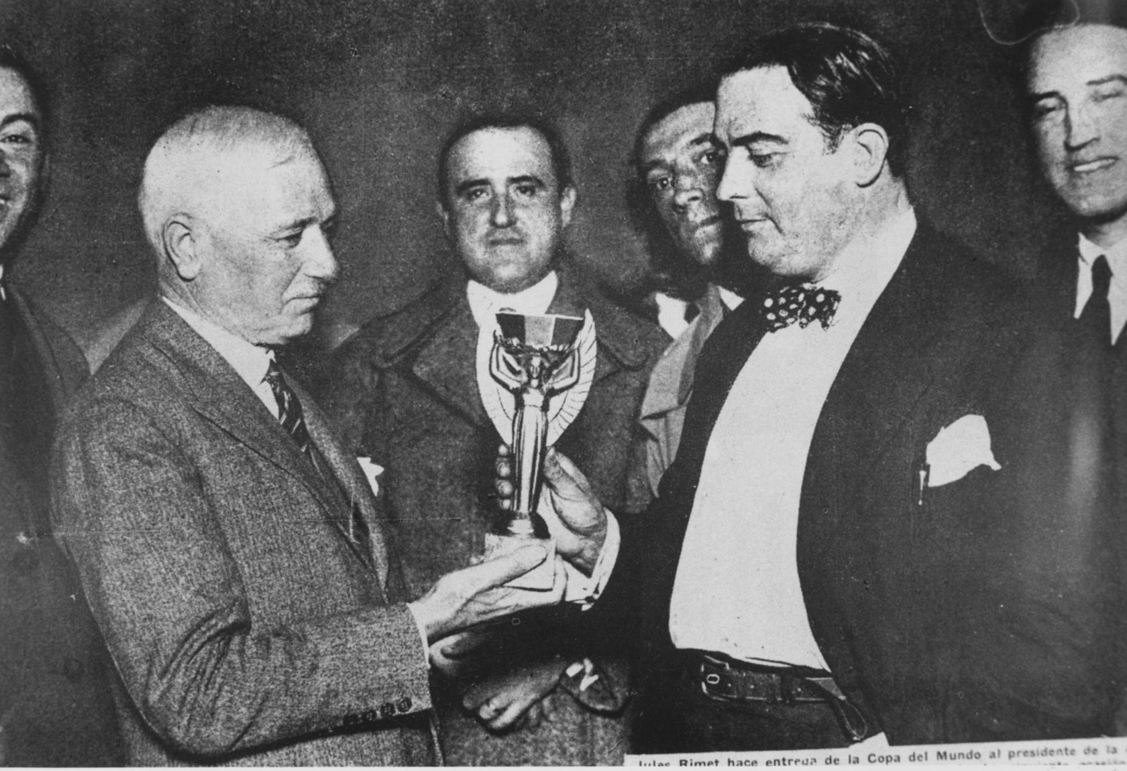

Third FIFA President Jules Rimet presents the Jules Rimet Cup to President of the Uruguayan Football Association, Paul Jude, following Uruguay's win over Argentina in the World Cup 1930 final, 30 July 1930

Designed by French sculptor Abel Lafleur, the Cup depicted the ancient Greek goddess of victory, holding a decagonal cup aloft. The statuette, weighing 3.8kg, was made of gold-plated sterling silver on a base of lapis lazuli. The trophy was nicknamed "Golden Goddess."

On the gold plaques affixed to each of the four sides of the Cup's base, the names of the nations were engraved that had won the World Cups from 1930 to 1970: Uruguay (1930, 1950), Italy (1934, 1938), Germany (1954), England (1966) and Brazil (1958, 1962, 1970).

Having won its third FIFA World Cup, the 9th editon in Mexico in June 1970, the Brazil team earned the right to keep the Cup in perpetuity, according to the then-current FIFA regulations.

It was only fair that the Cup was named after Rimet, the third President of FIFA, who had stood at the helm of FIFA for 33 years, following his appointment in 1921. It is to Jules Rimet that the world owes its first global football tournament. He had negotiated long and hard with top government officials, football federations and national teams. Rimet's obsession with the idea kept him on track until the first World Cup materialised in Uruguay in 1930. While leading FIFA, Rimet succeeded in boosting football's popularity dramatically worldwide, establishing the national team tournament as the premier four-year football highlight, and strengthening FIFA's authority. FIFA listed 56 member nations in 1954, when Rimet resigned from the office of President, nearly a triple of its early 1920s membership.

# The FIFA World Cup™

## History of the new trophy

After the handing-over of the Jules Rimet Cup to Brazil, FIFA had to commission a replacement trophy for the 1974 FIFA World Cup™. Fifty three submissions were received for the design tender, announced in 1971, from sculptors in seven countries. Silvio Gazzaniga, who would end up winning the commission, made two submissions. The earliest one was accepted.

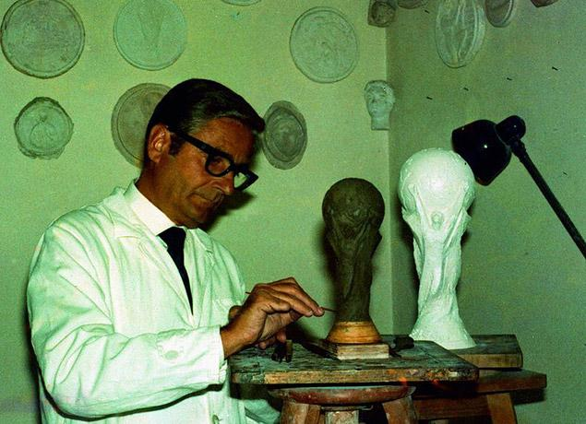

Sculptor Silvio Gazzaniga working on his World Cup Trophy, 1971

"To create a universal symbol, I was inspired by two fundamental images: those of a triumphant athlete and of the world," the artist said, explaining his FIFA World Cup Trophy concept. "I wanted to reflect the elation of the winning footballer – a man transformed by the enormity of his victory – but without the super human ego. This sporting hero who embraces the world in his arms, reflects the strength needed to make sacrifices day after day with his fellow team members and the universal characteristics of sport such as commitment and freedom."

They say the artist stayed closeted away in his studio for a week, working on the trophy. Gazzaniga himself would later admit the bulk of the work didn't take very long to do. However, the trophy being made of solid gold, the finer details conceived by the artist proved a challenge, and had to be added after the debut presentation of the Trophy.

